git challenges

- Resolve Merge Conflicts
  - Create a merge conflict intentionally (two users editing the same line).
  - Resolve the conflict and push the changes.

Create a file in master branch and enter the content in that file
add the files to tracking area by using command “ git add .”
commit the tracking file with commit message.
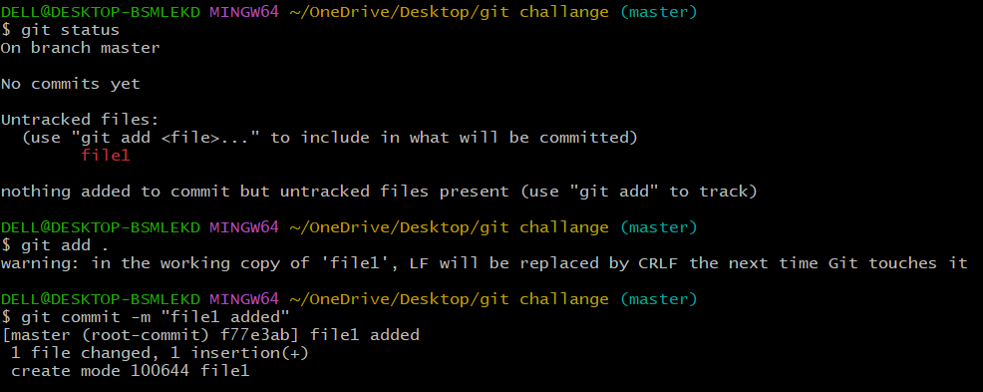
Create a branch and edit the file with similar content exists in master branch
Add the changes to tracking area
Commit the file
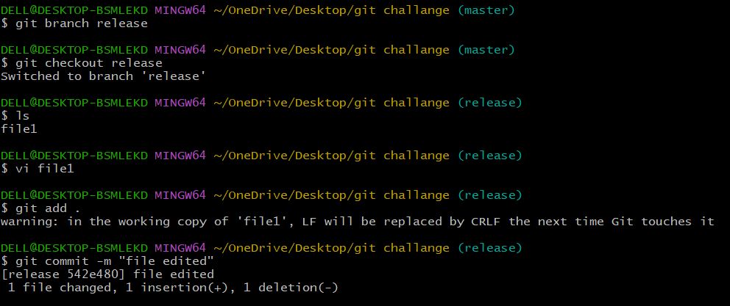
Switch to master branch and edit the content similar to other branch file and do commit.
Try to merge both the branches error will show as below (conflicts error) 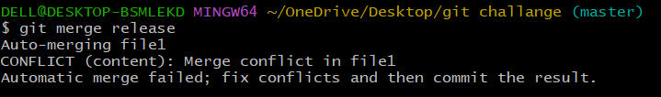
Edit the content in the file
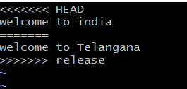
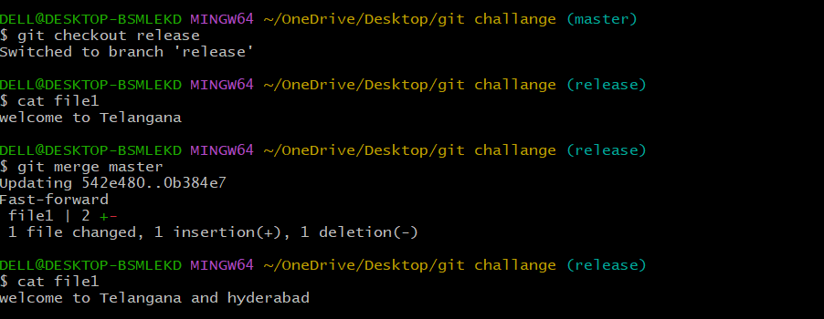

Recover Deleted Branch
Delete a local branch and then recover it using the reflog.

Create a branch and create a file in that branch
Add to tracking area and commit the file
Checkout to master branch and delete the created branch using “git branch -D branch name”
Use command “git reflog” to see the commit id of deleted branch
Copy the id and paste in “git branch branch-name id”
Check the branch list, the deleted branch will be recovered.
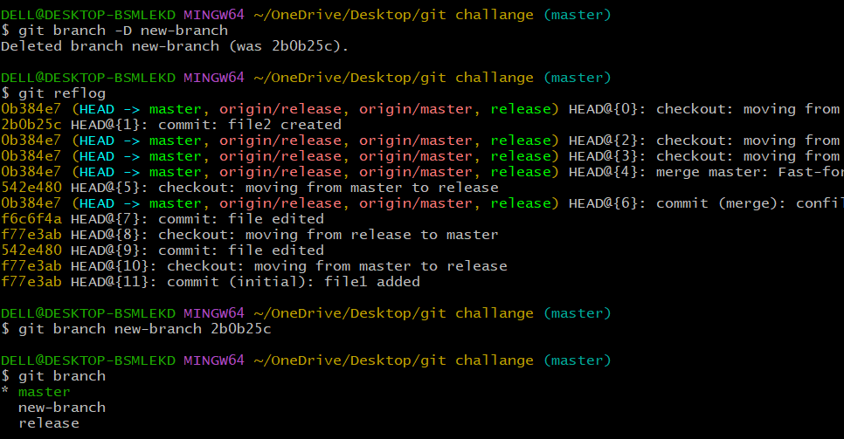

Undo Wrong Push
  - Push a wrong commit to GitHub, then undo it without losing history.
Created a file f1 and f2.
Added to tracking area and commit the tracked files.
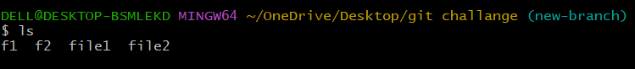
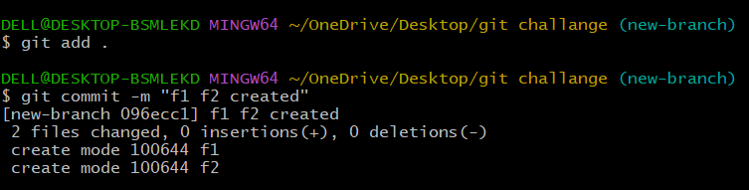
Delete f2 file and commit the file.
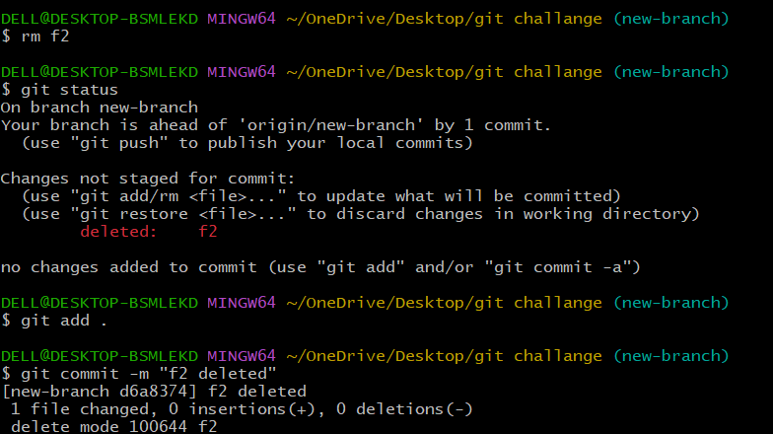

Push to central repo.
To do undo pull the files from central repo and by using ‘git revert’ command undo the wrong commit and push to central repo.
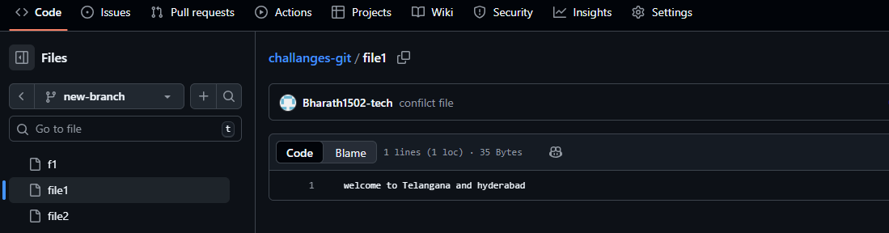
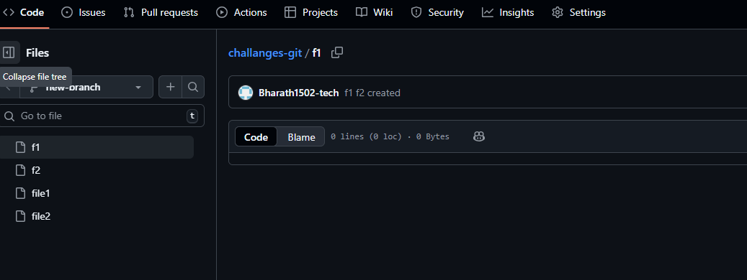

Amend a Commit
Make a commit, then add a missing file to it using git commit –amend

Create a file f3 and add to tracking area
Do commit for added file f3.
Create another file f4 and add to tracking area
Commit the file to existing commit by using command “git commit –amend” and edit the commit message of previous commit.
Push to central repo.

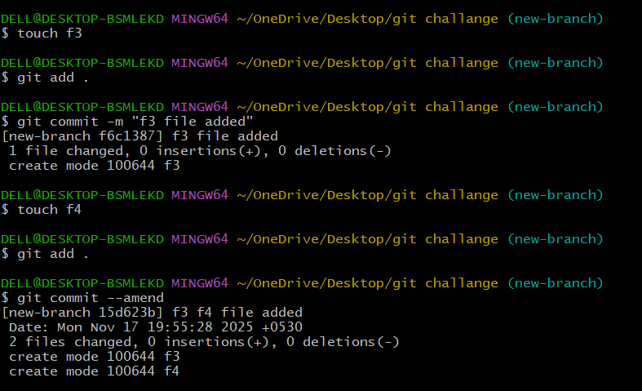

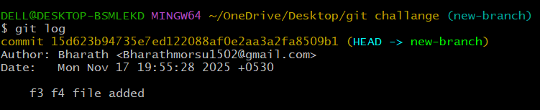

Cherry-pick a Commit
Take a specific commit from one branch and apply it to another branch.

Copy the commit id from previous branch
In current branch use command “git cherry-pick commit id” so that the commit id files will be copied to current branch.

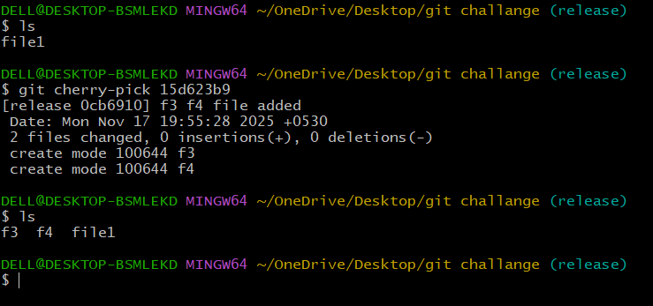

Interactive Rebase
Reorder and squash multiple commits into a single clean commit.

Use command “git rebase -i HEAd~3” to add multiple commits in one commit
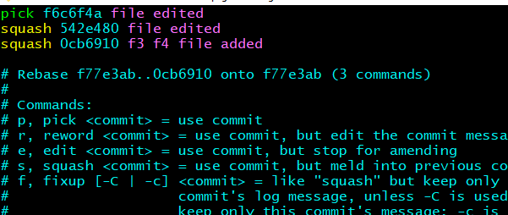
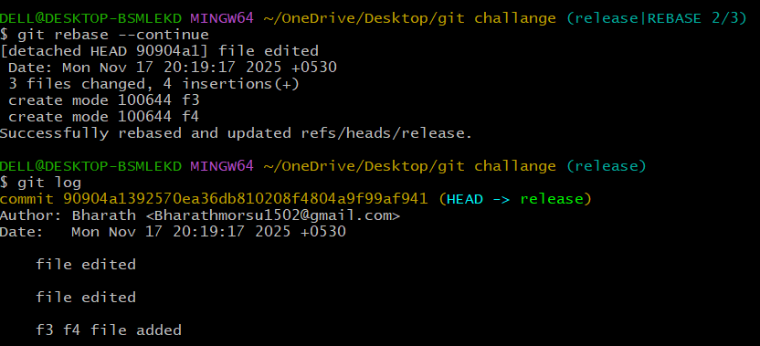

Tagging & Release
Create a version tag (v1.0), push it to GitHub, then delete and restore it.

Created a tag v1.0.0 and pushed to central repo.
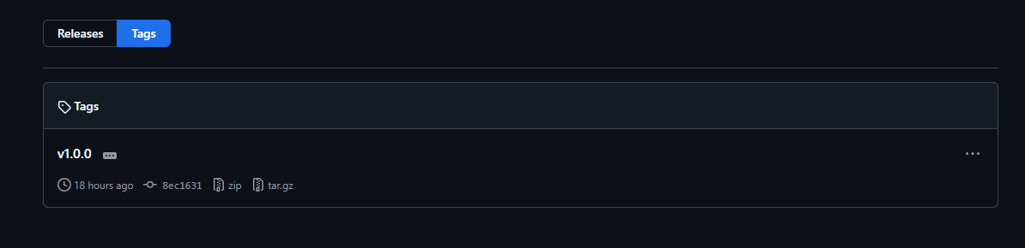
Delete git tag using command “git tag -d v1.0.0”
Use command “git log –oneline” commits will be displayed with id.
Copy the commit id and paste with command “git tag v1.0.0 commit id”
to restore.
Use command “git tag” to show the available tags.
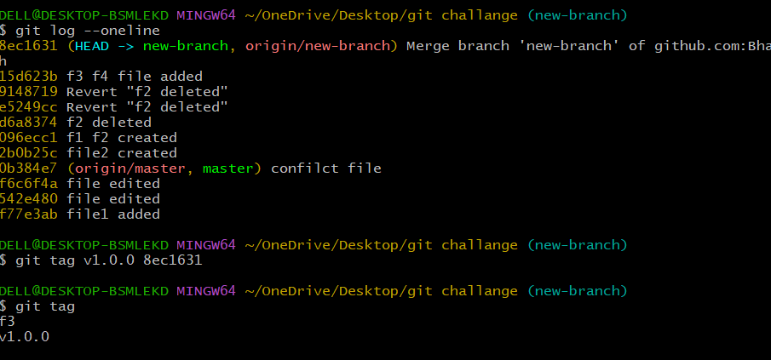

Clone with Sparse Checkout
Clone only a subdirectory of a repo using sparse checkout.
This clones the repository without checking out any files “git clone –no-checkout git@github.com:Bharath1502-tech/challanges-git.git”
Use command “git sparse-checkout init” to enable sparse checkout mode
Use command “git sparse-checkout set challenges-git” this command helps to which directory you want to checkout.
Git now downloads only that folder from the repository instead of the entire
repo.
ls -R . used to verify that sparse checkout.
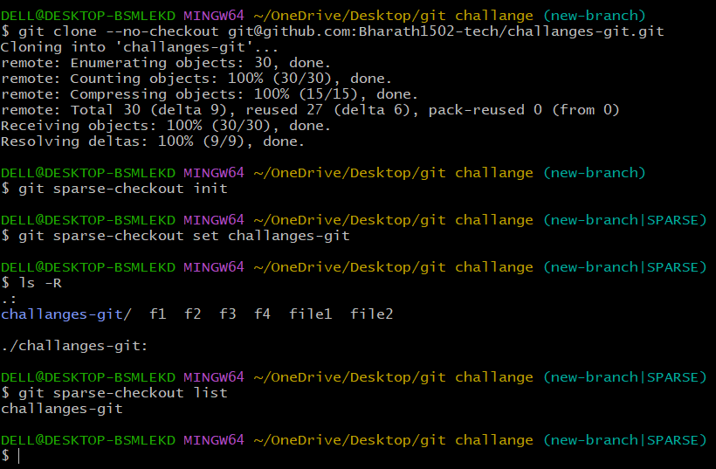

Reset vs Revert Challenge
Demonstrate the difference between git reset --hard and git revert in a repo.
Use command “git log” to show the commit id’s
By using “git revert commit id ” we can revert the deleted or removed files.
use command “git reset” we can move the file from tracking area to untracking area.
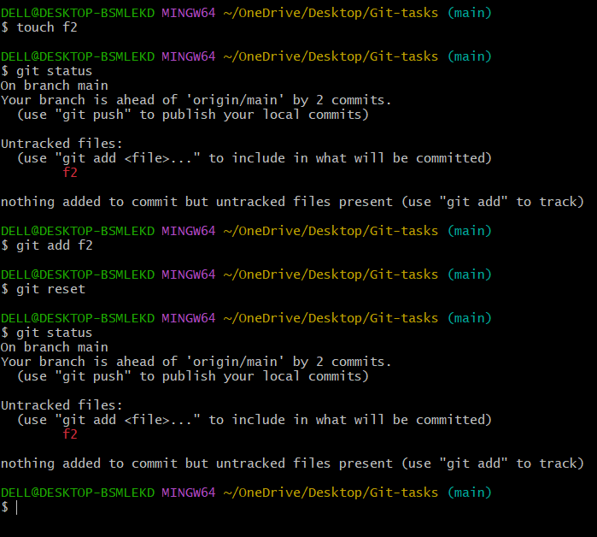
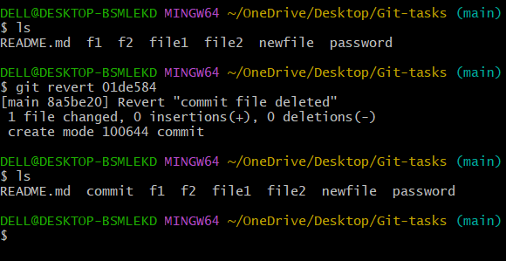

Detached HEAD Challenge
Checkout a specific commit (detached HEAD state) and create a new branch from it.

Git log --oneline to show the logs and commit id
Git checkout with commit id, that will switch to that commit id
Created and switch branch by using command “git checkout -b branch name”
Check the branch list using commane “git branch”.
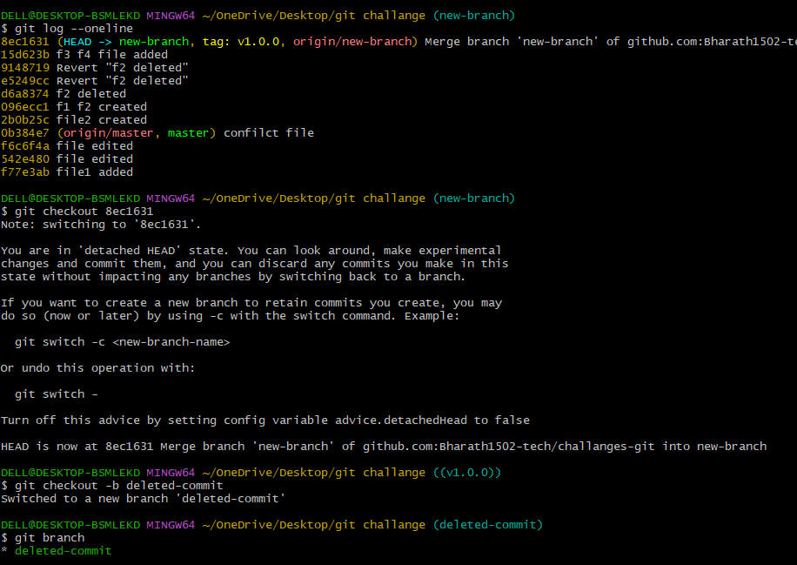

Squash Merge vs Rebase Merge
Show the difference between squash merge and rebase merge with evidence.

Squash merge:
Combined all commits from release into one commit.
pushed to central repo.
Rebase merge: rebase master branch and merge with release branch
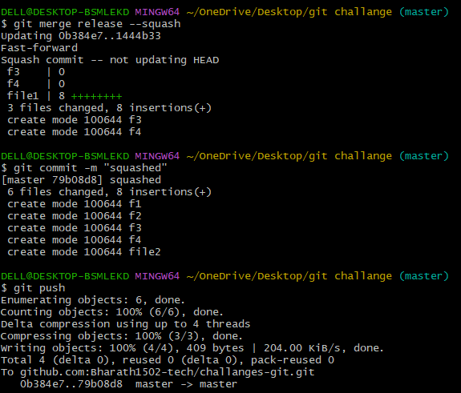
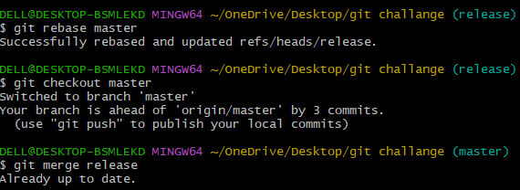

Fork & Pull Request Workflow
Fork a repo, make a change, and submit a pull request to the original repo.

Click the Fork button in the top-right corner of the page. Select your GitHub account as the owner of the fork. You can optionally rename the fork and add a description.
Click Create fork. A copy of the repository will be created under your account.
Made changes by adding a file and made a pull request in github account.
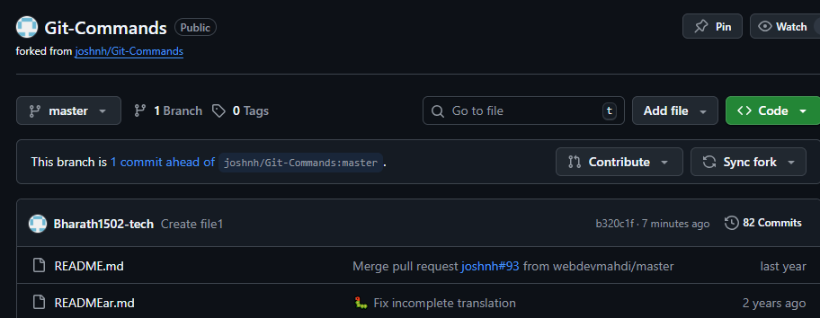

Recover Lost Commit
Commit something, reset hard, and then recover it using git reflog.
Created a file and commit the file
Deleted the commit using command “git reset –hard HEAD~1”
Found the commit in git reflog
Restored it using command “git reset --hard commit-id”
Verified recovery commit using git log.
